
Hi [Name],
I’ve signed up for the LandAid SleepOut 2026 - and I’d love you to join me.
Last year, 118,000 young people had nowhere safe to call home. To help change this, LandAid is rallying the industry for our biggest-ever property SleepOut on Thursday 5 March 2025 — with the option to take part from home or in London, Birmingham, Manchester, Leeds, Liverpool, Cambridge, Edinburgh, or our newest location, Cardiff. This year’s event is even more special, marking 40 years of LandAid driving action to end youth homelessness.
The night offers a small glimpse into the challenges young people face, with stories from those who’ve overcome homelessness and insights into the projects your fundraising will support. Although the LandAid SleepOut does attempt to replicate homelessness or rough sleeping, it offers a small glimpse into some of the challenges young people might face, to help us all understand and support them better.
Last year, over 1,200 people raised £650,000. This year, the goal is £908,000 - and every participant helps get us closer.
It’s on our industry; it’s on us to make a difference.
Register here.
Got questions? The FAQs are here, or you can contact the LandAid Events team at sleepout@landaid.org.

Thanks for considering it!
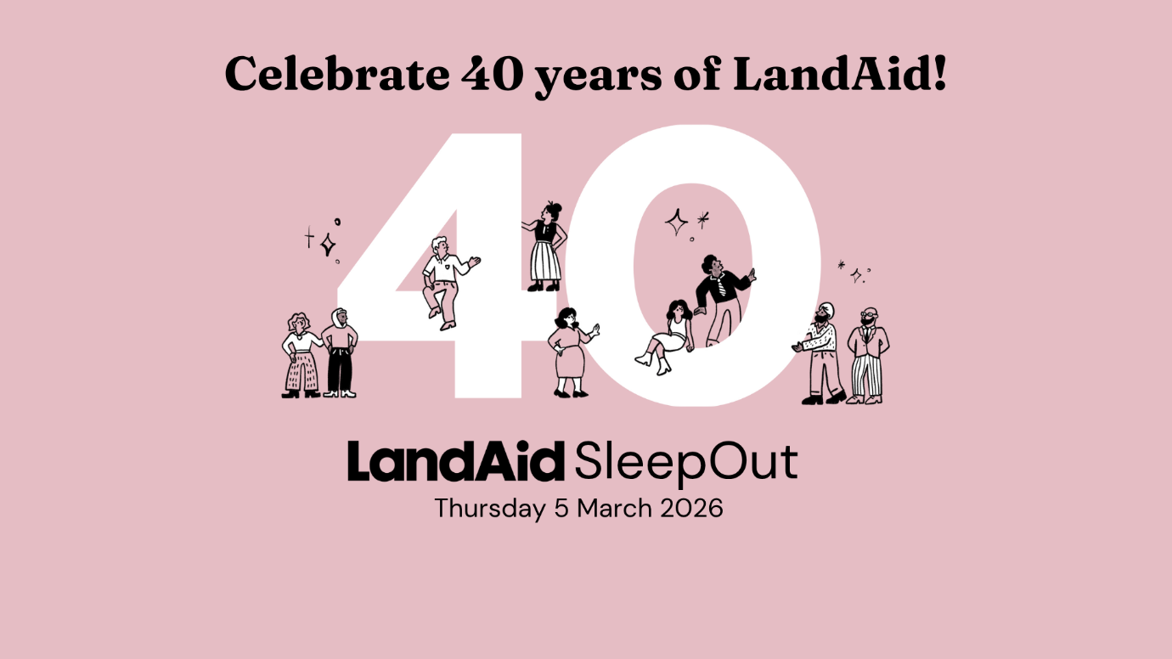
Best,

